**Demographics**

1. ***Opioid Overdose Deaths by Gender***

This visualization analysis includes U.S. citizen who died from a drug overdose between 2010 to 2016. Overall, men are more likely than women to use the opioid drugs and is more likely to lead to overdose death. Of the decedents 127,080 were male and 68,916 were female.

**Figure 1** represents the number and data distribution of male and female died from opioid overdose. It is important to note that males disproportionately experienced opioid overdose deaths compared to females because males comprise about 49.2% percent of the U.S. population yet accounted for 64.8% percent of the opioid overdose deaths between 2010 to 2016. However, females comprise 50.8 percent of the population and accounted for 35.2 percent of the opioid overdose deaths reported in 2010 and 2016 period. Note: gender ratio statistical data from the United States Bureau shows that the female percentage in 2017 is 50.8%.

<https://www.census.gov/quickfacts/fact/table/US/LFE046216>

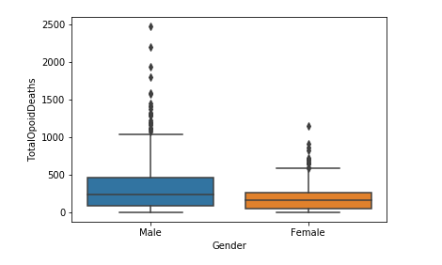

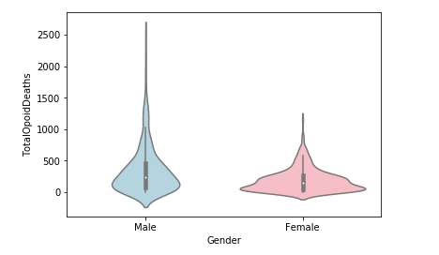

Figure 1 Opioid Overdose Deaths by Gender

1. ***Opioid Overdose Deaths by Age***

**Figure 2** shows that the total number of opioid overdose deaths by designated age groups.

From 2010 to 2016, most opioid overdose deaths occurred in people aged 25-34. The 25-34 age group represents the largest percentage of deaths, which is 24.3%. The second percentage of deaths is the 35-44, which is 21.9%.

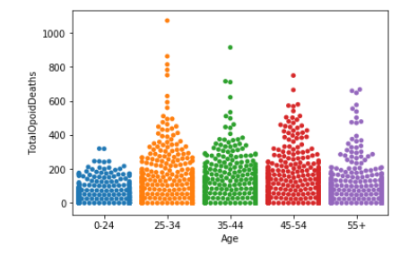

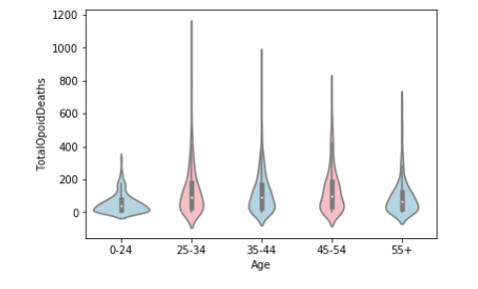

Figure 2 Opioid Overdose Deaths by Age Group

1. ***Opioid Overdose Deaths by Race***

Figure 3 shows that from 2010 to 2016, 160,962 deaths were identified as White (84.6%), 12,588 were identified as Black (6.7 percent), 12,704 were identified as Hispanic (6.8 percent). The racial ratio for overdose deaths also matches with the racial demographics in the United States.

<https://www.census.gov/quickfacts/fact/table/US/PST045217>

Note: racial statistical data from the United States Bureau shows that in 2017 Whites comprise approximately 76.6%, Blacks comprise approximately 13.4%, and Hispanics comprise approximately 18.1%.

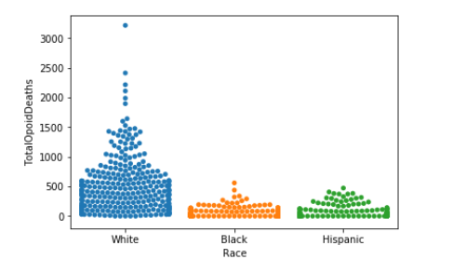

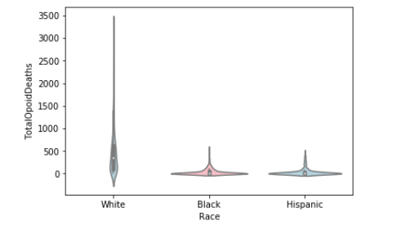

Figure 3 Figure 2 Opioid Overdose Deaths by Race